Scope : 1 Mobile Combustion
Fuel Wise Categorized - Fule ni category wise bdlase emission factors & aa HGV ma to different j che bdha factors

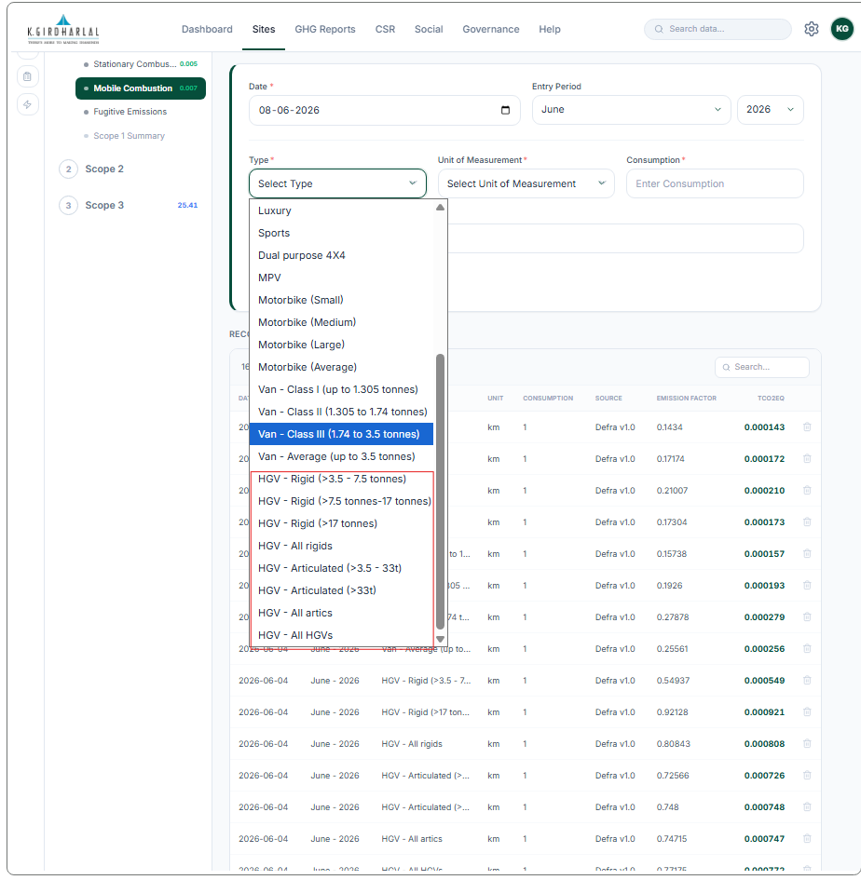

Scope : 2 Purchased Electricity
Add Emission Factor Source : CaDI 2025
India: 0.95182
Botswana: 0.97662
United Arab Emirates : 0.3652
Supporting Document attach krvanu tab add krvanu

Purchased Heat and Steam
Onsite & District both - Emission Factor : 0.179647
Renewable Electricity Generation

Add County
Add Emission Factor Source : CaDI 2025 in place of self Reported
India: 0.95182
Botswana: 0.97662
United Arab Emirates : 0.3652
Supporting Document attach krvanu tab add krvanu

Scope : 3 Employee Commute
Commute Type wise badha tab add thse
For Ex:Commute Type: Cars (by size)
Fuel Type
Diesel | Petrol | Hybrid | CNG | LPG | Plug-in Hybrid Electric Vehicle | Battery Electric Vehicle

Vehicle Type:
Small car
Medium car
Large car
Average car

Unit of Measurement: Km /Miles
For motorbike -ama fule type selection ny avvu joye

Activity | Type | Unit
Motorbike | Small | km
 |  | miles
 | Medium | km
 |  | miles
 | Large | km
 |  | miles
 | Average | km
 |  | miles

Activity | Type | Unit
Taxis | Regular taxi | passenger.km
 |  | km
 | Black cab | passenger.km
 |  | km

Activity | Type | Unit
Bus | Local bus (not London) | passenger.km
 | Local London bus | passenger.km
 | Average local bus | passenger.km
 | Coach | passenger.km

Activity | Type | Unit
Rail | National rail | passenger.km
 | International rail | passenger.km
 | Light rail and tram | passenger.km
 | London Underground | passenger.km

Purchased Goods & Services
Emission factor bdha ma j alg che
Loop ma - Option missing - Primary material production
Re-used

Transmission & Distribution Loss due to Imported Electricity
Add Emission Factor Source : Defra v 1.0
India: 0.0188
Botswana: 0.0188
United Arab Emirates : 0.0188

Supporting Document attach krvanu tab add krvanu

Upstream & Downstream transportation of goods
See Emission factor sheet
Bulk Import no Option nathi
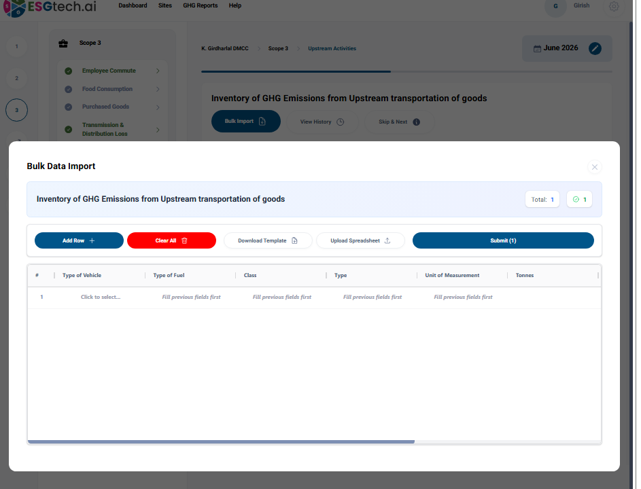

Waste Disposal
Emission factor bdha ma j alg che
See Emission factor sheet

Water Treatment
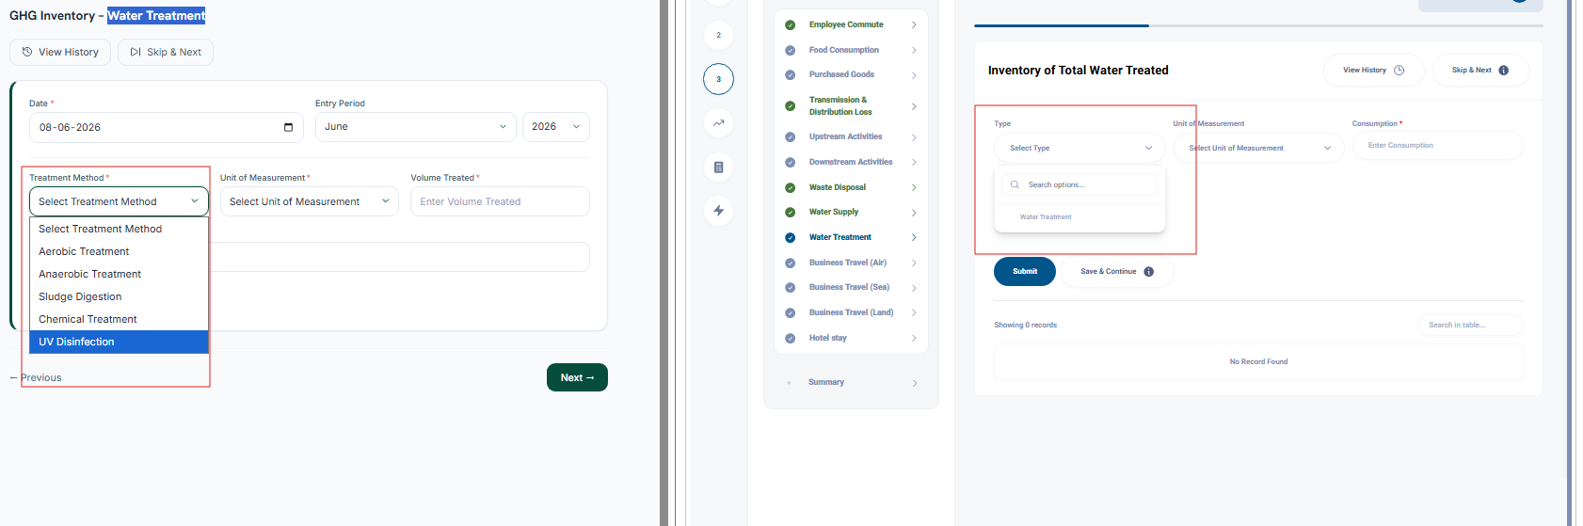
Treatment Method | Unit of Measurement | Emission Factor
Water treatment | cubic metres | 0.17088
 | million litres | 170.87549

Business travel By Air
See Existing portal details -Type with Rf & without rf options missing
Origin airport & destination airport selection features-Employee commute,Business travel by air,Business travel by Land,
Submit button not working
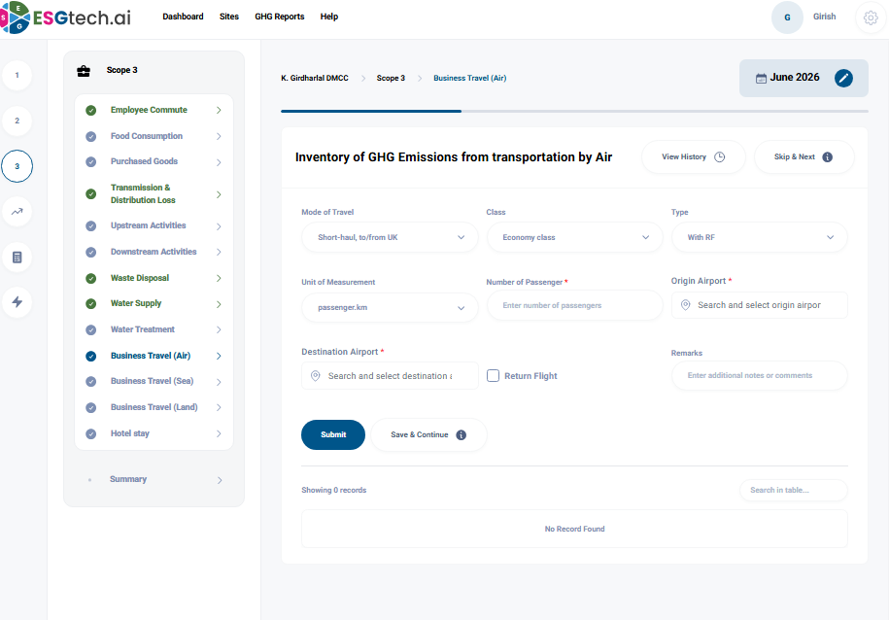

 |  |  |  | With RF | Without RF
Activity | Haul | Class | Unit | kg CO2e | kg CO2e
Flights | Domestic, to/from UK | Average passenger | passenger.km | 0.22928 | 0.13552
 | Short-haul, to/from UK | Average passenger | passenger.km | 0.12786 | 0.07559
 |  | Economy class | passenger.km | 0.12576 | 0.07435
 |  | Business class | passenger.km | 0.18863 | 0.11152
 | Long-haul, to/from UK | Average passenger | passenger.km | 0.15282 | 0.09043
 |  | Economy class | passenger.km | 0.11704 | 0.06926
 |  | Premium economy class | passenger.km | 0.18726 | 0.11081
 |  | Business class | passenger.km | 0.33940 | 0.20083
 |  | First class | passenger.km | 0.46814 | 0.27701
 | International, to/from non-UK | Average passenger | passenger.km | 0.14253 | 0.08420
 |  | Economy class | passenger.km | 0.10916 | 0.06449
 |  | Premium economy class | passenger.km | 0.17465 | 0.10318
 |  | Business class | passenger.km | 0.31656 | 0.18701
 |  | First class | passenger.km | 0.43663 | 0.25794

Business travel By sea

Add tab number of Passenger
Ads Source: Defra v 1.0
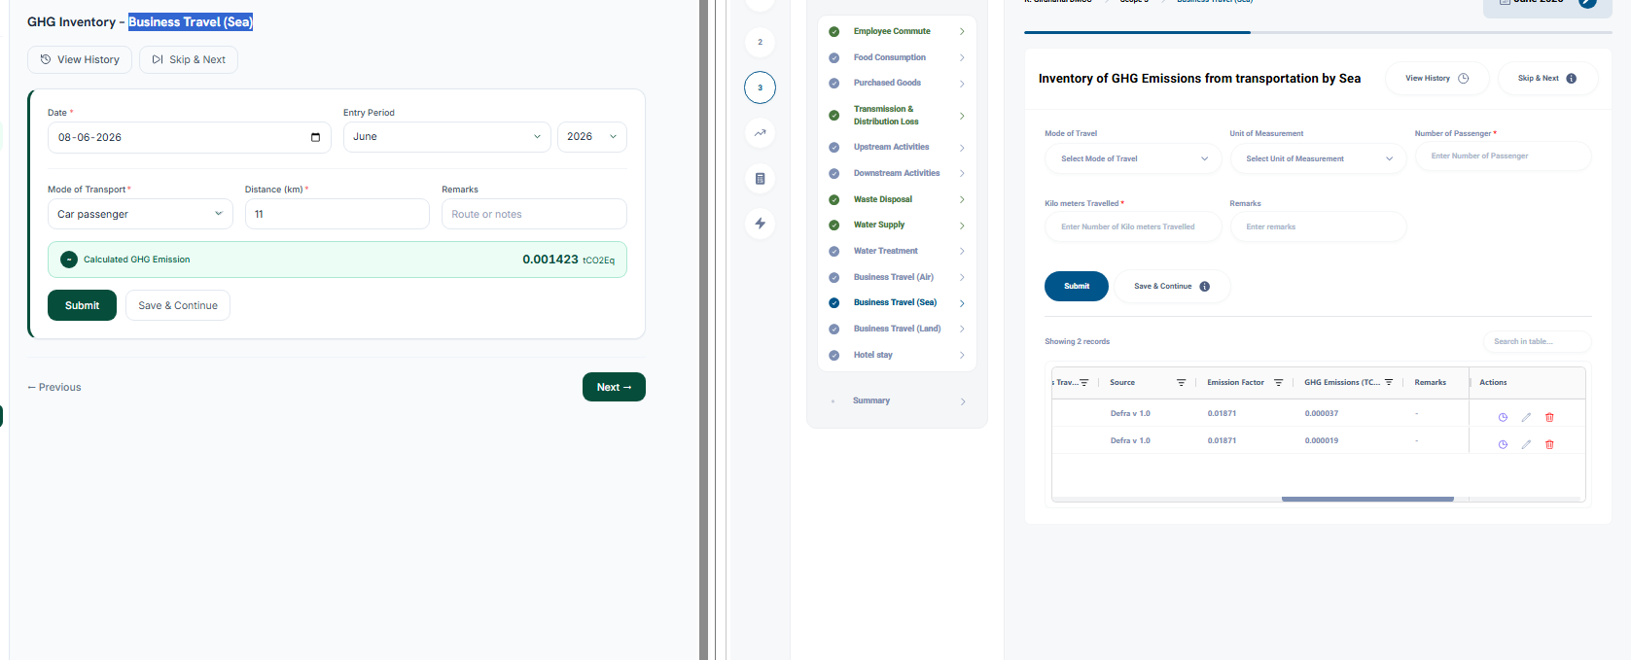

Activity | Type | Unit | kg CO2e
Ferry | Foot passenger | passenger.km | 0.01871
 | Car passenger | passenger.km | 0.12933
 | Average (all passenger) | passenger.km | 0.11270

Business Travel (Land)
See Existing portal details & emission sheet

Hotel Stay
Calculated value 00 in all county
In scope in submit button not work in
Employee Commute

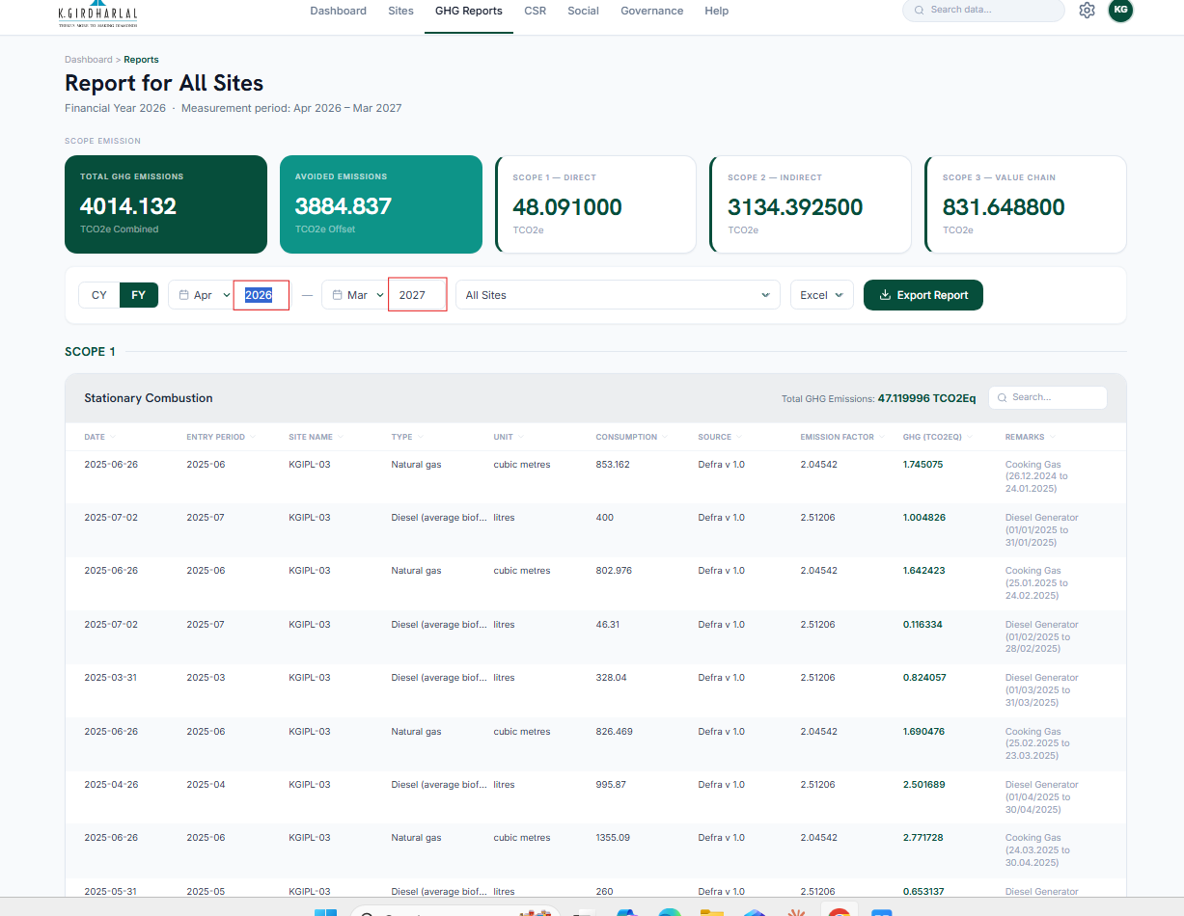

Not able to change the year or may be filled data not showing here.

